paper title
(STYLE= “PaperTitle”)
Name of Author(s) (Include Co-Authors if same affiliation) (Style = “AuthorName”)
Affiliation (Style = “AuthorAffiliation”)
Name of Co-Author(s) (Style = “AuthorName”)
Affiliation (Style = “AuthorAffiliation”)

ABSTRACT (STYLE = “Heading 1”)
The font, sizing, and spacing for the section titles are defined Microsoft Word Styles (shown in parenthesis for each header). Convert additional headings, subheadings, and body text in the paper to the appropriate style by selecting the proper Style name from the Style box on the ribbon. All body text is in Times New Roman 12 font (Style=”Normal”), left justified, with a single empty line space between paragraphs.
The Normal style includes a 12-point space after each paragraph to include an “empty line” between paragraphs (rather than manually typing paragraph returns after each paragraph). Submit papers in MS Word or PDF format.

Nomenclature, Acronyms, Abbreviations (STYLE = “Heading 1”)
α_{λ} spectral absorptivity
…

INTRODUCTION (STYLE = “Heading 1”)
This paper template is available as an aid in preparing the papers for TFAWS 2019 and is not a required format. The papers are informal and the authors are welcome to submit alternate formats. The primary considerations should be content, clarity, and convenience.

MAIN HEADING(S) (STYLE = “Heading 1”)
This is the main body text using Normal style. Insert figures, with or without text wrapping, either in the text or at the end of the text section. The wrapping setting for the example below is “Top and Bottom,” as opposed to allowing the text to wrap around the figure with the “Square” or “Tight” wrapping style. Double-click on the image below to see text wrapping options. Color figures are permissible, but should be able to convey the same information if displayed/printed in black and white. Recommended practice is to use Word automatic insert and numbering for captions of figures and tables. Reference figures with Word’s Insert Cross-reference feature. For example, see Figure 1. (If you highlight the ‘Figure 1’ text, you will see that it is a field that will update if the figure number changes). The styles for figure and table captions differ between “Caption – Figure” and “Caption – Title”, respectively, because the table caption style is marked as ‘Keep with Next’ so that the caption of the table will always remain with it. Include captions below figures and above tables.

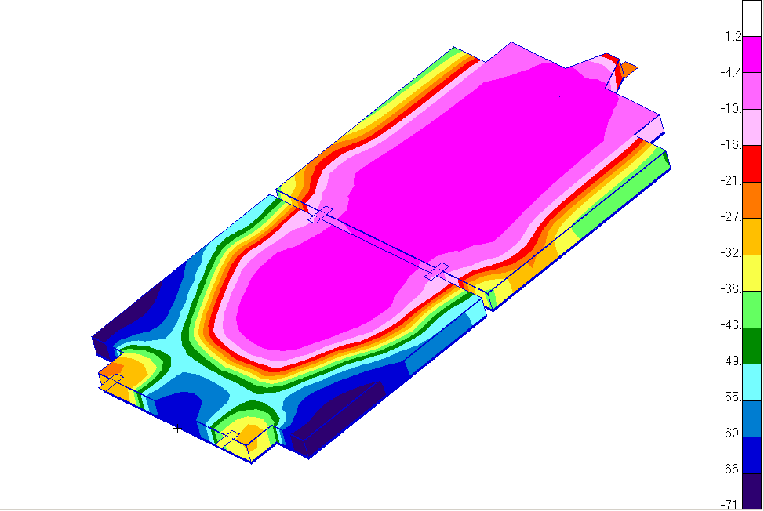
Figure 1. Figure title should be in sentence case with a period.

Table 1. Table Title Should Use Initial Capital Letters and No Period
Table content

Subheading (Style = “Heading 2”)
Subheading body text…
Bulleted Lists (if required)
- List items are in Bulleted List style
- List (continued)

Numbered Lists (if required)
- List items are in Numbered List style
- List (continued)

Sub-Subheading (Style = “Heading 3”)
Sub-subheading text…

CONCLUSIONS (STYLE = “Heading 1”)
Conclusion text…

ACKNOWLEDGEMENTS (STYLE = “Heading 1”)
Author’s acknowledgements. (Optional)

CONTACT (STYLE = “Heading 1”)
Additional contact information or background on the author. (Optional)

REFERENCES (STYLE = “Heading 1”)
1. (Note: Reference citations in the text use the number in superscript, e.g., ¹ for the first reference. Automatic insertion of endnote references in Word is recommended.)
2. Reference format (e.g., APA, MLA, etc.) is up to the author’s discretion.

Other suggestions:
To utilize Greek symbols, please use the Symbol font.
Number figures and tables independently.
Number equations referenced in the text.

