Simulation of Heat Transfer of Al2O3/Water Nanofluid- Effect Volume Fraction
AmirReza Radmanesh ª, Nihad Dukhan ^{b}
^{a,b} Mechanical Engineering Department, University of Detroit Mercy, Detroit, MI, USA
ª radmanam@udmercy.edu, ^{b} dukhanni@udmercy.edu

ABSTRACT
The literature has a considerable number of disagreements with regard to the performance of nanofluids as heat transfer fluids. In this paper, simulations of heat transfer of nanofluid made from aluminum oxide Al2O3 suspended in deionized water are presented. Three solid particle volume concentrations were tested: 0.25, 0.75 and 1.5%. Key properties of each nanofluid were obtained from correlations available in the literature. Each nanofluid flowed in a circular pipe having an internal diameter 5.25 cm and a length 15.24 cm. The pipe was subjected to constant heat flux of 74948 W/m². At the inlet, the fluid’s temperature was 298 °K, and the entrance velocity was 0.064 m/s (uniform profile). The single-phase model for each nanofluid was utilized. All simulations were conducted utilizing ANSYS Fluent. The mesh-independent results showed that the total temperature increased with increasing volume concentration, and was higher that of water. As expected, the temperature increased in the flow direction. For the low concentration of 0.25%, there was negligible enhancement of heat transfer compared to water. Certainly more simulations are needed and verification of results must be conducted via experiments. Studies must also address effect of flow rates on heat transfer at various concentrations.

INTRODUCTION
Nanofluids are suspensions of solid nanoparticles (<100 nm) of metal (e.g. copper, silver, and gold) or metal oxide (e.g. alumina, titania, and iron oxide) in conventional base fluids. Nanoparticles can also be carbon-based such as graphene nanosheets and carbon nanotubes. Base fluid can be water, oil, ethylene glycol, paraffin, and refrigerants. The common based fluids have poor thermal conductivities compared to nanoparticles. Additives (surfactant or dispersants) are used to keep the nanoparticles in suspension and prevent them from agglomeration.
Adding nanoparticles to base fluids improves the thermal conductivity and the convective heat transfer coefficient. However, nanoparticles produce an increase in viscosity if compared to the base fluids and sometimes cause non-Newtonian behavior. It is largely agreed upon that the improvement in thermal performance offered by nanofluids is a result of the increased effective thermal conductivity. This key property is a function of the thermal properties of both the carrying fluids and the suspended nanoparticles. Nanofluids have the potential to become the next generation coolants in many engineering applications, such as vehicle thermal management systems, power generation, solar collectors, reactors, thermal management of electronics, fuel cells, and boiler flue gas temperature reduction.
Nanofluids have been around since 1995 [1], and scientific interest in nanofluids has experienced an exponential increase. Yu et al. [2] investigated convective heat transfer of Al2O3-polyalphaoleon (PAO) nanofluids including both the spherical and the rod-like nanoparticles. They stated that in a convective flow, the shear-induced alignment and specific motion of the particles should be included in the interpretation of experimental data of the nanofluids heat transfer
Bianco et al. [3] reported numerical results for turbulent forced convection flow of water-Al2O3 nanofluid in a circular tube for a constant and uniform heat flux on the bounding surface. Conflicting results on the heat transfer enhancement using nanofluids in forced and natural convection are reported in the literature [4]
Certainly more systematic studies are required for more understanding of heat transfer due to nanofluids flow in conduits. This paper is a small step in that direction. It investigates, via simulation, the effect of nanofluid flow rate and volume fraction on heat transfer in an open circular tube having constant heat flux applied on its outer surface.

SIMULATION
- Theoretical Model of Nanofluid
There are two primary theoretical models of nanofluids: the single-phase model (SPM) and the two-phase model (TPM). The SPM treats nanoparticles and base-fluid as a single-phase flow, and assumes that local thermal equilibrium holds between the nanoparticles and the base fluid because the size of nanoparticles is so small. The SPM also assumes that there is no slip between their molecules. Mass, momentum, and energy equations, which are used for conventional liquids, could also be applied to single-phase nanofluids. In this case, only thermophysical properties of nanofluids need to be determined and inserted in the equations. Applying the single-phase model for nanofluids produces results that are strongly dependent on adopted thermophysical properties. Many researchers [5-7] reported that heat transfer in nanofluids can be modelled using the SPM.
The two-phase model (TPM) is preferred by some researchers because there is concentration variation of nanoparticles in the flow. The TPM thus treats nanoparticles and the base-fluid as two different phases. Two sets of governing equations are needed- one set for each phase. There is a debate in the literature about which analysis provides a better prediction. Recently, Wen et al. [8] presented a study of the heat transfer and flow behavior of ZnO ethylene glycol (EG)/water nanofluid inside two multiport mini channels. Numerically, single phase model gave better predictions for both Nusselt number and friction factor, while the mixture model severely overestimated the Nusselt number but showed a reasonable friction factor prediction. The SPM was adopted in the current study for simplicity.
- Properties of Nanofluids
Properties of a nanofluid depend on base fluid, nanoparticles and the interactions between the two. The suspension of nanoparticles in a base fluid certainly alter the fluid’s thermophysical properties, i.e., density, viscosity, specific heat, and thermal conductivity. These properties depend on nanoparticle concentration and size as well as temperature. Prior to employing nanofluids in engineering simulations and analysis, it is indispensable to have an accurate knowledge of their relevant properties.
One important variable in nanofluids is the volume fraction , which is defined as the solid nanoparticles volume divided by the volumes of the base fluid and the nanoparticles volume (the mixture volume) prior to mixing:
(1)
The volume fractions investigated in this simulations were: 0.25%, 0.75% and 1.5% and the nanofluid was made by aluminum oxide Al2O3 in water. Key thermophysical properties of the nanoparticles and the DI water used are given in Table 1.
Table 1 Properties of Nanoparticles and water
Property | Al2O3 | Water
ρ (kg/m³) | 3900 | 998.2
k(w/m.k) | 42.34 | 0.6
C_{p}(j/Kg.k) | 880 | 4182
µ(kg/m.s) | NA | 0.001003
Key properties of the nanofluid for different concentrations were calculated from the following correlations. The density from [9,10]:
(2)
The specific heat from [9,10]:
(3)
Viscosity from [9]:
(4)
Thermal conductivity [9,11]:
(5)
Here the subscripts s, f or bf, nf refer to solid nanoparticles, fluid or base fluid, and nanofluid, respectively.
Table 2 Nanofluid’s Properties for Three Concentrations
(%) | 0.25 | 0.75 | 1.5
ρ (kg/m³) | 1005.4 | 1019.9 | 1041.7
k(w/m.k) | 0.604 | 0.613 | 0.6262
C_{p}(j/Kg.k) | 4149.9 | 4087.3 | 3996.57
µ(kg/m.s) | 0.001009 | 0.001022 | 0.001042

- Heat Transfer System
The heat transfer problem that was simulated is described schematically in Fig. 1. Basically, there is an aluminum pipe with constant cross section having an internal dimeter of 5.25 cm and an external dimeter of 6.05 cm. The length of the pipe is 15.24 cm in the flow direction. The pipe is heated on its external surface by constant heat flux. A coolant (water or nanofluid) enters the pipe at the inlet (to the left) and flows to the right. The entering flow had a uniform velocity profile. The exit of the pipe was open to the atmosphere. This arrangement is common on heat transfer applications, for example, condensing steam in power plants, cross-flow heat exchangers, water heating, and the like.
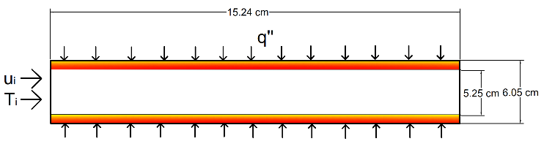
Fig 1 Schematic of the Heat Transfer Problem

- Boundary Conditions
The following conditions were applied at the boundaries:
At the inlet, the fluid temperature T_{i} =298 °K, and entrance velocity u_{i} = 0.029m/s. On the external surface of the pipe, a constant uniform heat flux q″ = 74948 W/m² was applied. It should be noted that the velocity profile at the entrance was uniform.
- Description of Simulations
All simulations were conducted utilizing ANSYS Fluent 2021 R1 (Ansys Inc., Canonsburg, PA) on a local station AMD Ryzen 7 1st Gen - RYZEN 7 1700X Summit Ridge (Zen) 8-Core 3.4 GHz (3.8 GHz Turbo) with dual processors, 64 cores, and 32.0 GB RAM. All meshes consist of uniform square-shaped elements with near-wall higher density to capture any temperature fluctuations. Even though the Reynolds number was Re = 1635, which makes this pipe flow laminar, a k-ε turbulent model was adopted in the simulation. This is treatment is common for nanofluids analysis, see for example [12]. For each run, it took approximately 25 minutes for convergence.
- Mesh Independence
The mesh independent study has been done for various mesh densities to obtain a mesh converged solution with optimum density. It is crucial to optimize the size of the cells and the density of the elements to get an exact solution. The total temperature is calculated across the test section for different mesh densities. Once the average total temperature across the test section does not change as the element is refined by more than 2%, then the mesh independence study is recognized to be an optimized mesh resolution. Based on the mesh independence study, the final meshes have a total of 60,720 elements.
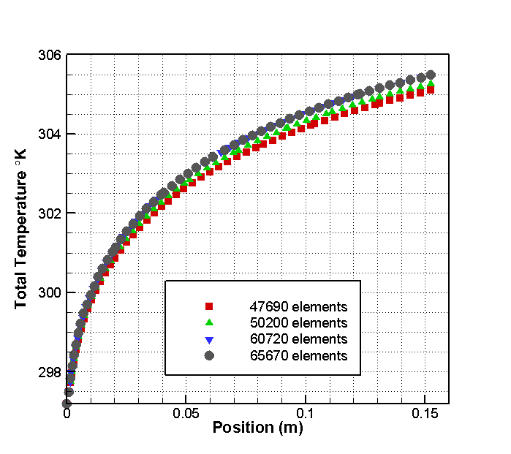
Fig 2 Mesh Independence

RESULTS
The obtained temperature along the pipe for the three volume concentrations of the nanofluids are shown in Fig. 3. The case for water is also shown for comparison. It is clear from this figure that adding nanoparticles increases the temperature compared to water. However, this increase is very small of low concentration and increases as the nanoparticles volume concentration increases. The increase in temperature is rather significant for the high concentration of 1.5%. The low concentration of 0.25% is not pursuing for practical applications.
It is noted that the temperature increase as the distance from the entrance increases for all cased. This is due to the fact that the fluid keeps absorbing heat from the heated wall as it travels along the pipe.
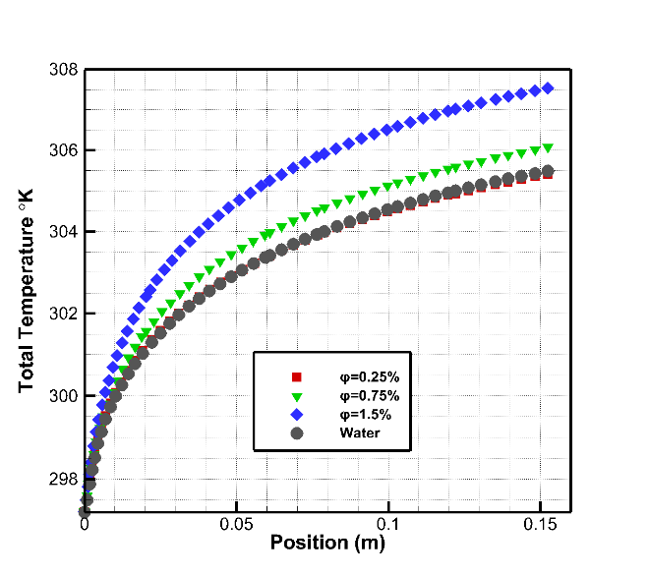
Fig 3 Total Temperature at Wall as a Function of Distance from Entrance

CONCLUSIONS
Since there are divergent results with regard to heat transfer enhancement of nanofluids, more simulation and experimental are needed in this area. This paper described a first attempt for simulating a common convection heat transfer in heated pipe. The cooling fluid was water then a nanofluid. Results showed clearly that the nanofluid with concentration above 0.75% enhances heat transfer over water. However, concentration below 0.25% do not enhance heat transfer, and cannot be recommended for applications. Certainly more simulations are needed and verification of results must be conducted via experiments. Studies must also address effect of flow rates on heat transfer at various concentrations.

REFERENCES
- U.S. Choi, J.A. Eastman, Enhancing thermal conductivity of fluids with nanoparticles, Proceedings, ASME International Mechanical Engineering Congress and Exposition: San Francisco, CA, 1995, p.99-105.
- Yu, L.; Liu, D.; Botz, F. Laminar convective heat transfer of aluminapolyalphaole in nanofuids containing spherical and non-spherical nanoparticles. Exp. Therm. Fluid Sci., 2011, 37, 72-83.
- Bianco, V.; Manca, O.; Nardini, S. Numerical investigation on nanofluids turbulent convection heat transfer inside a circular tube. Int. J. Therm. Sci., 2011, 50, 341-349.
- Khalil M. Khanafer and Kambiz Vafai, The Role of Nanoparticle Suspensions in Thermo/Fluid and BiomedicalApplications in : Nanoparticle Heat Transfer and Fluid Flow Edited By W. J. Minkowycz, E Sparrow, J. P. Abraham, 2012, CRC Press, pp 25-67.
- E.V. Timofeeva, J.L. Routbort, D. Singh, Particle shape effects on thermophysical properties of alumina nanofluids, J. Appl. Phys. 106 (1) (2009) 014304.
- E.V. Timofeeva et al., Base fluid and temperature effects on the heat transfer characteristics of SiC in ethylene glycol/H2O and H2O nanofluids, J. Appl. Phys. 109 (1) (2011) 014914.
- W. Williams, J. Buongiorno, L.-W. Hu, Experimental investigation of turbulent convective heat transfer and pressure loss of alumina/water and zirconia/water nanoparticle colloids (nanofluids) in horizontal tubes, J. Heat Transfer,130 (4) (2008) 042412-1–042412-7.
- Tao Wen, Lin Lu, Shaojie Zhang, Hong Zhong, Experimental study and CFD modelling on the thermal and flow behavior of EG/water ZnO nanofluid in multiport mini channels, Applied Thermal Engineering 182 (2021) 116089.
- Khashi'ie, N.S., et al., Flow and heat transfer of hybrid nanofluid over a permeable shrinking cylinder with Joule heating: A comparative analysis. Alexandria Engineering Journal, 2020. 59(3): p. 1787-1798.
- Kim, S., et al., Comparison of CFD simulations to experiment for heat transfer characteristics with aqueous Al2O3 nanofluid in heat exchanger tube. International Communications in Heat and Mass Transfer, 2018. 95: p. 123-131.
- Farajollahi, B., S.G. Etemad, and M. Hojjat, Heat transfer of nanofluids in a shell and tube heat exchanger. International Journal of Heat and Mass Transfer, 2010. 53(1): p. 12-17.
- Arun Kumar Tiwari, Summaiya Javed, Hakan F. Oztop, et al., Experimental and numerical investigation on the thermal performance of triple tube heat exchanger equipped with different inserts with WO3/water nanofluid under turbulent condition, Int. J Ther Sci, V. 164, June 2021, 106861

