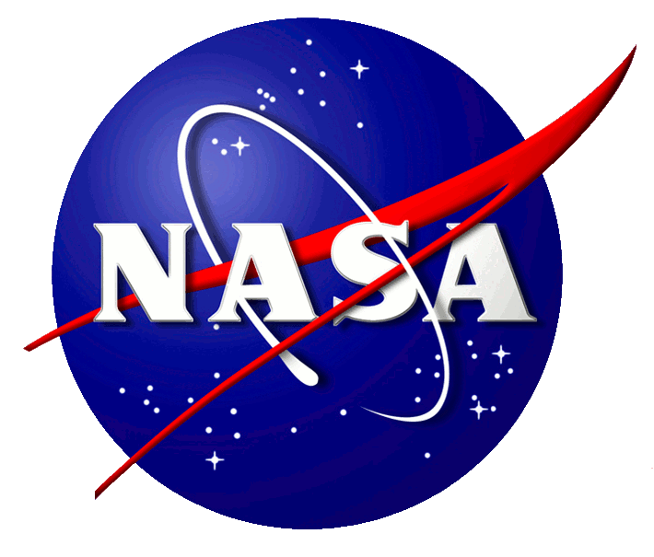
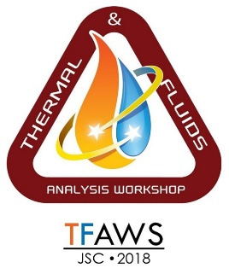
Call for Papers
Thermal & Fluids Analysis Workshop (TFAWS) 2018
NASA Johnson Space Center
Galveston Island Convention Center • August 20-24

Abstract submission deadline is May 25th, 2018

The 2018 NASA Thermal & Fluids Analysis Workshop includes presentations of original research and technical work. Paper sessions provide the opportunity for those in the thermal-fluids community to present their work to peers. This allows for greater dissemination of technical material within the community and provides a valuable forum for discussion about applications and advancements within various disciplines.
During TFAWS 2018, paper sessions will be divided into the following topic areas: Active Thermal/Fluids, Passive Thermal, Aerothermal, Cryothermal, and Interdisciplinary. Descriptions of these topics can be found below.
Active Thermal/Fluids
- Active thermal systems and control: components, thermal systems, analysis and testing
- Fluids and CFD: analysis, design and test
- Life support: environmental control and life support systems
- Analytical model correlation to existing test or flight data
Passive Thermal
- Passive thermal systems and control: design, analysis, build, and test
- Spacecraft thermal protection systems including tiles, ablative systems, plume impingement, and ascent/entry aerothermal heat management
- Radiative heat transfer, analytical and experimental approaches
- Studies related to MLI, coatings, thermophysical/optical properties, and surface finishes
- Analytical model correlation to existing test or flight data
Aerothermal
- Aerothermodynamics: design, analysis, build, and test
- Aerothermodynamic performance for aircraft and spacecraft operation in earth and other planetary atmospheres
- Heating due to high speed flight and jet and rocket plume impingement
- Free molecular heat transfer, analytical and experimental approaches
- Analytical model correlation to existing test or flight data
Cryothermal
- Cryogenic system design: design, analysis, build, and test
- Cryogenic Fluid Systems
- Gas compression technologies
- Passive multistage cryogenic radiators
Interdisciplinary
- Multi-disciplinary problems: design, analysis, build, and test
- Fluid management and modeling techniques as applied to propulsion
- Vibration and acoustics in the launch environment
- Integrated analyses of chemical reactions, electromagnetic interactions, micromechanics, structural motion
- Modeling/Testing error approximation and verification/validation techniques
- Technology innovations, current and in-development
- Creating environments of inclusion to enable innovation
- Lessons Learned
Abstract & Paper Submission Guidelines
You are invited to submit papers for presentation during the conference session. The deadline for abstracts is May 25th, 2018. Submissions should be sent to jsc-tfaws-2018-papers@mail.nasa.gov. You will be notified via e-mail of the acceptance of your abstract.
In addition to the abstract, please specify the topic area for your submission (Active Thermal/Fluids, Passive Thermal, Aerothermal, Cryothermal, and Interdisciplinary), and indicate if the final paper/presentation will include any export controlled (ITAR) material. ITAR sessions will be provided based on demand.
Manuscript and presentation templates will be provided to authors. While full paper are encouraged, they are not required to give a conference presentation. Typically, twenty minutes will be allocated for each presentation and ten minutes for questions from the audience. Instructions for electronic manuscript submission will accompany acceptance of the abstract. It is the author’s responsibility to ensure that presentation content is not restricted by law, contract, or prohibited in any way from being presented at this conference.
Clearance/Copyright
Submitted work must be unclassified and approved for public release by the appropriate company and/or government agency. Please allot time for this authorization process. Government employees are expected to completed Document Availability Authorization (DAA) paperwork prior to final submission. The submission must be original work from the author(s) without any portion of the material infringing on any copyright.
Presenters are required to fill out a “TFAWS 2018 Presentation Clearance & Permission to Publish” form prior to their presentation.

