Thermal Transient Testing of Semiconductor Components – Fundamentals

- Abstract

The presentation covers the fundamentals of thermal transient testing of semiconductor devices and packages for thermal characterization and how to enhance electronics thermal design of reliable products to achieve goals for size, weight, power and cost by combining use of test and thermal simulation.

The topics will include the application of electrical test methods to determine thermal metrics with confidence, how achieve highest accuracy in package to system level thermal simulation accuracy through model calibration, and how to use thermal transient testing for failure diagnosis during thermal reliability studies and also in quality assessment.

As the functionality of thermal simulators gets more and more complex, measurement techniques also improve. Thermal engineers face an increasingly difficult task to make the right selection from the existing tools. Beside this problem the precise determination of thermal performance indicators such as R_{thJC} or R_{thJB} is becoming more and more difficult as the package geometries become more complex. The thermal characterization of novel power packages hosting a number of dies is a major issue where the standard definitions cannot be applied anymore.

The answer to these challenges may lie in a combined measurement and simulation approach. Measurements yield a structure description of materials having different conductivities; simulation gives the clue what certain sections in the measured structure correspond to. TIM materials are very difficult to model, as neither their conductivity nor their thickness can be defined with high accuracy even by the designer of a given package. Well planned thermal measurements are suitable tools to measure the in-situ resistance of these materials so that they can be later on used for accurate model creation.

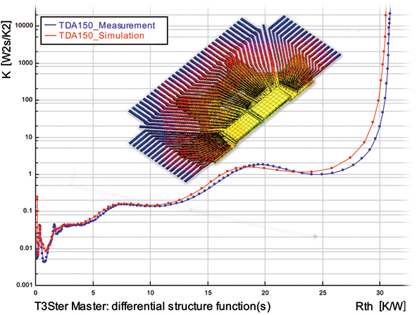

Figure 1: Comparison of simulated and measured structure functions

As the measurement and simulation techniques mutually support each-other the ultimate solution for package thermal characterization may be the simulation model creation based on real measurements. In the final presentation we will discuss these approaches in details and demonstrate their applicability for designing more reliable electronics for aerospace applications.

