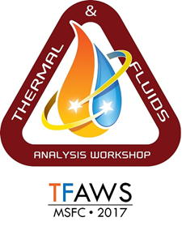
Solicitation for Vendor Participation
Please respond by May 19, 2017.
TFAWS 2017 – Huntsville, AL
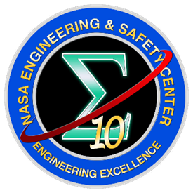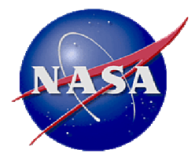

The 28th Thermal and Fluids Analysis Workshop, TFAWS 2017, sponsored by the NASA Engineering and Safety Center and hosted by NASA Marshall Space Flight Center, is scheduled for August 21 to August 25, 2017 at The Westin in Huntsville, Alabama. The three technical areas of focus for TFAWS 2017 are Passive Thermal, Active Thermal, and Aerothermal. An Interdisciplinary session will also be included for those submissions that do not fit in a single category.
Software Vendors
Software training classes will be available from the software vendors themselves, as well as technical experts who utilize these software programs in their daily work. This presents a unique opportunity for training in programs that participants may be unfamiliar with or to advance previous knowledge and experience. Previous software training courses included COMSOL, Siemens PLM NX Space Systems Thermal, Siemens PLM FEMAP, Thermal Desktop, FloCAD, TD Direct, Fluent, Star CCM+,TSS, MSC Patran Thermal, MSC Apex, FloEFD, Generalized Fluid System Simulation Program (GFSSP), Fully Implicit Ablation and Thermal Analysis (FIAT) Program, ESATAN-TMS, Data-Parallel Line Relaxation (DPRL), Configuration Based Aerodynamics (CB Aero), NEQAIR, Thermal Analysis Results Processor (TARP) and Stat‐Ease.
Software companies have three options for participating in TFAWS aside from participating in Paper Sessions. One option is to have a booth on display with information. The second option is to host a hands-on training course, typically scheduled in two to four‐hour blocks of time that covers tutorials with conference guests. The final option is to give a short demo on the capabilities of the software or specific applications for approximately one hour.
Hardware Vendors
Hardware companies have two options for participating in TFAWS aside from participating in Paper Sessions. Additional presentation options include a booth on display with information and/or a short demo on the capabilities of the hardware or specific applications. Demos are typically scheduled in twenty minute to one-hour blocks, depending upon the vendor’s preference.

If your company is interested in participating as a vendor, please fill out the form, which follows, and return to MSFC-TFAWS2017@mail.nasa.gov by May 19, 2017.

Please type or print legibly

Software or Hardware: |  | Company  Name:
Product Title: |  | Address:
Name: |  | City, State,  Zipcode
Phone:
Cell Phone: |  | Fax:
Email: |  | Website:
Date(s) of  attendance: |  | Special  Requests:

 | Booth Desired:
 | Provide Hands‐On Training  Course: |  | Total Length of Hands‐On Training  Course:
 | Provide Demo: |  | Total Length of Demo:
Training or Demo Description:
Questions?
For questions related to vendor participation, please contact Matthew Cross at matthew.f.cross@nasa.gov or (256) 544-1724.

