Performance evaluation of reverse osmosis (RO) pre-treatment technologies for brackish ground water
Ali I. Shehata¹, Mohamed Mahmoud Ismail², Ayman Abo-Bakr Mahmoud², Mohamed M. Abo Elazm¹

¹Mechanical Engineering Department, Arab Academy for Science, Technology and Maritime Transport, Alexandria, Egypt
²Repair Workshops, Alexandria, Egypt
Abstract:
Desalination of brackish groundwater in Egypt has great potential with respect to the availability of the resource. All major aquifer systems in Egypt contain huge quantities of brackish groundwater. The exploitation of this resource is still limited. With the current cheap price of brackish water desalination, there is a growing interest towards its exploitation. Brackish water RO plants in Egypt confirm the potential of this solution. This paper presents the study of the effect of variation of different operating conditions on the performance of brackish groundwater RO unit. This was achieved experimentally by using brackish water RO (Reverse Osmosis) desalination test rig constructed to simulate environmental conditions and operational parameters for coastal Mediterranean brackish groundwater RO units. Results of experiments at constant feed water parameters showed that: Feed water pressure increases the permeate flow rate and the recovery ratio increase while brine rejected, permeate TDS and specific energy consumption decrease. Feed water TDS increases the permeate flow rate and the recovery ratio decrease while brine rejected, permeate TDS and specific energy consumption increase. Feed water temperature increases the permeate flow rate, permeate TDS and the recovery ratio increase while brine rejected and specific energy consumption decrease. Samples of experimental output parameters were used as ROSA input parameters to check the accuracy of experimental results. However, there were deviations between the experimental results and ROSA results that did not exceed 10 %.

Introduction
Egypt falls within the arid belt of North Africa and Southwest Asia, bordered on its northern coast by the Mediterranean Sea and on its eastern coast by the Red Sea. It covers a total area of about one million km². The main source of surface water in Egypt is the River Nile. Under the 1959 treaty, 55.5 billion m³ were allocated to Egypt and 15.5 billion m³ to the Sudan [1]. Due to the rapid growth of the population and the increasing consumption of water in agriculture, industry, domestic use, etc., it is expected that Egypt will rely to some extent on groundwater to develop the new projects [2].Brackish groundwater desalination is one of Egypt’s most potentially significant water resources. Most aquifer systems in Egypt contain high quantities of brackish groundwater [3].
The main aquifers in Egypt are generally formed either in granular rocks (sand and gravel) or in fissured and karstified (limestone) rocks. Seven different aquifers can be classified (five in sandy gravel formations and two in limestone and hard rock formations) according to the hydrogeological characteristics as follow [4]:
- Nile valley aquifer (granular rocks)
- Nile delta aquifer (granular rocks)
- Moghra aquifer (granular rocks)
- Coastal aquifers (granular rocks)
- Nubian sand stone aquifer (granular rocks)
- Fissured hard rock aquifer (limestone rocks)
- Fissured and karstified aquifers (limestone rocks)
Coastal aquifers are found in different localities along the Mediterranean region including Sinai and in the Red Sea region. The Mediterranean aquifer is recharged from rainfall, runoff water and from the high-pressure water in the Nubian Sandstone aquifer below. The salinity of groundwater varies between 3000 and 5000 ppm.
Due to its low salinity and the current low price of brackish water desalination there is a growing interest towards its exploitation.
Since desalination technologies have been developed substantially over the last fifty years, especially with the development of "Reverse Osmosis" (RO) technology in the sixties leading to significant reductions in the cost of desalination. Reverse osmosis is the finest level of filtration available [5]. The RO membrane acts as a barrier to all dissolved salts and inorganic molecules, as well as organic molecules. Water molecules, on the other hand, pass freely through the membrane creating a purified product stream. Rejection of dissolved salts is typically 95 % to greater than 99%.The applications for RO are numerous and include desalination of brackish water or seawater for drinking purposes, biomedical separations, wastewater recovery, food and beverage processing, purification of home drinking water and industrial process water. The performance of RO reverse osmosis system is affected by many factors such as the feed water composition, feed temperature, feed pressure, and permeate recovery ratio [6]. Several studies have been conducted in an attempt to study the effect of these parameters to improve the performance of RO unit.
Abou-Rayan et al studied the effect of the feed water temperature, the feed pressure, the inlet pH and the feed water salinity on the performance of a small-size brackish water reverse osmosis (RO) desalination test-rig [7]. The maximum value of recovery ratio has been obtained from the feed water pressure increase. The increase of feed water pressure or temperature results in a recovery ratio increase while the increase of feed water salinity or feed water pH leads to a decrease in recovery ratio. Hamid et al made a technico-economical evaluation of small-scale (100 L/day) reverse osmosis desalination unit [8].The recovery rate of the RO unit was evaluated vs. different operating conditions such as operating pressure, raw water TDS and water temperature. The small capacity unit was able to produce a treated water of a 100 mg/L TDS with a conversion rate ranging between 25 and 37%. The water treatment cost was evaluated at 0.01 E/L which is approximately the tenth of that of bottled table water. Aish investigated the chemical and bacteriological water qualities of different small scale of (RO) desalination companies in the Gaza Strip [9]. The results of the chemical and bacteriological parameters were compared with the World Health Organization (WHO) standards. All chemical analyses of RO produced water were within the allowable WHO limits. Bacteriological analyses illustrate that 25% of the produced water samples exceeded the maximum allowable value of the total coliform bacteria. Ziraked et al studied the concentrations of a number of physical, chemical and biological quality parameters in raw and treated water of Bandar Lengeh water Desalination Plants and Performance of RO plants for seawater and costal groundwater desalination [10].The results demonstrated the quality of feed water and pretreatment plays an extremely important role in operational problems such as fouling of RO systems. El-Harrak et al made a performance evaluation for a brackish water reverse osmosis plant for agricultural application, located in Dokkala Region in Morocco [11] which indicated poor performances after few months of operating and frequent shutdown. The pretreatment scheme was reviewed to find out the causes of anomalies. The problem was solved by removing chlorination and sodium bisulfate steps from the pretreatment. Al- Bazedi et al reviewed and analyzed a case study for a 3000 m³/day RO desalination plant in Ain El Sokhna-Suez, Egypt [12]. The Design of the plant has been adopted using ROSA software as well as basic design equations for RO system design. Detailed economic study has been adopted to evaluate the feasibility of the plant. The cost calculations of the RO plant illustrated that the main factors which affect the cost of the produced water are membrane cost and the power consumption cost, whereas the chemical treatment represents almost 10% of the total cost Although previous studies have addressed performance evaluation of brackish water RO unit either theoretically or experimentally but none of them carried out these studies theoretically and experimentally at the same time. In the present study the effect of variation of different operating conditions on the performance of brackish groundwater RO unit was investigated experimentally then studied theoretically.
An experimental test rig was designed and constructed, used to perform experiments to simulate the environmental conditions and operational parameters for coastal Mediterranean brackish groundwater RO units. The effects of changing feed water pressure, feed water TDS and feed water temperature on recovery ratio, brine flow rate, permeate flow rate, permeate TDS and specific energy consumption were studied. Samples of experimental output parameters were used as ROSA input parameters to check the accuracy of experimental results.
Experimental Setup
The experimental test rig was constructed to perform experiments to simulate the environmental conditions and operational parameters for coastal Mediterranean brackish ground water RO units. The experiments have been carried out in a lab at the Naval research and calibration center. The study includes 150 experiments using brackish water at 6 different feed water salinity, 1000, 2000, 3000, 4000, 5000 and 6000 ppm. For feed water TDS =1000 ppm, 25 experiments at 5 different feed water temperature ranging 15, 20, 25, 30 and 35 °C, for each temperature value 5 experiments at 5 different pressure values ranging 12, 16, 20, 24, 28 bar. The effects of changing temperature and pressure are also performed for TDS= 2000, 3000, 4000, 5000 and 6000 ppm. During experiments, pretreatment for water is not needed because the saline solution is prepared by dissolving a certain amount of sodium chloride in tap water to obtain the desired TDS.
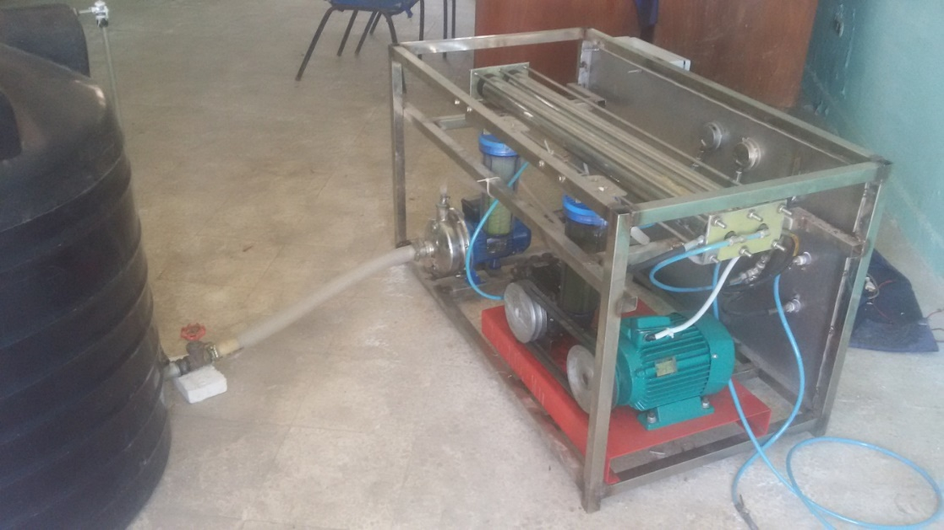
Fig (1) Reverse Osmosis test rig

The test rig consists of the following equipment shown in figure (1). The unit consisted of 500 liters feed water tank made from polyethylene, 100 cm height and 85 cm diameter, equipped with a scale meter to measure the level of feed water in the tank.
A suction valve is used to allow water to pass from the tank to the feed pump. The feed water pump is Centrifugal type, Pompa-pump Italy, made from stainless steel = 1.2-4.8 m³/hr, H = 19-16 m which pumped feed water from feed water tank to 2 cartridge filters. One 5 microns filter, one 20 microns filter are used to remove suspended particles from feed water stream with maximum operating pressure = 7 bar at flow rate = 2 m³/hr. A high-pressure pump is piston type ANNOVI, Q = 10 L/min at pressure up to 100 bar equipped with 3 phase, 3 hp, 220 V motor, used to create high pressure of feed stream through 2 membranes. Its pressure is controlled by the throttling valve. The high-pressure pump motor is connected to frequency inverter VACON type with rated output current 15.8A, output frequency up to 60 Hz, to control motor frequency at range from 20 to 50 Hz. The membranes module consists of 2 spiral wound polyamide type from Filmtec company model BW30- 2540 of Length = 1016 mm and diameter = 61 mm, maximum operating temperature 50°C at pH range = 4-11, installed inside 2 stainless steel pressure vessels that withstand up to 50 bar operating pressure. A throttling valve located at the outlet brine line from the membrane is used to adjust the pressure of the high-pressure pump to the required value. Potable water passes through permeate line to 50 liters polyethylene tank used to collect the permeate.
Results and Discussions
Experimental Results
To study the effect of a certain parameter on the system performance, other parameters were kept constant during the work. Experimental tests were carried out to investigate the influence of the main operating parameters (feed water pressure, feed water TDS and feed water temperature) on the plant performance (permeate flow rate, brine flow rate, recovery ratio, permeate salinity and SEC). The influence of the main operating parameters on the RO unit are graphically shown as follow:
- Effect of changing feed water pressure and TDS
At constant feed water flow = 1 m³/hr, constant feed water temperature = 25°C by changing feed water TDS at 1000, 2000, 3000, 4000 5000 and 6000 ppm, It is found that during the operating range of feed water pressure ranging from 12 to 28 bar, increasing the feed water pressure leads to:
- Increasing permeate flow rate, that may be due to increasing feed water pressure above the osmotic pressure of feed water which increase the permeate flow rate. On the other hand by increasing feed water TDS, permeate flow rate decreases. This is due to increasing of water density and viscosity as well, that passes through the membrane of the tested R.O. unit as shown in figure (2).

Figure (2) feed water pressure vs. permeate flow rate at different TDS

- Decreasing brine flow rate, that may be due to increasing the permeate flow rate at constant feed water flow rate. On the other hand, increasing feed water TDS, brine flow rate increases. This is due to decreasing permeate stream that comes out from the membranes of the tested R.O. unit as shown in figure (3).
- Increasing recovery ratio, that may be due to increasing the permeate flow rate. On the other hand, at any feed water TDS, recovery ratio increases by decreasing feed water TDS. This is due to increasing permeate stream that comes out from the membranes of the tested R.O. unit as shown in figure (4).
- Decreasing permeate TDS, that may be due to increasing the membrane salt rejection. On the other hand, at any feed water TDS, permeate TDS decreases by decreasing feed water TDS. This is due to increasing the membrane salt rejection of the tested R.O unit as shown in figure (5).

Figure (3) feed water pressure vs. brine flow rate at different TDS

Figure (4) feed water pressure vs. recovery ratio (RR) at different TDS

- Decreasing SEC, that may be due to increasing the permeate flow rate. On the other hand, at any feed water TDS, SEC increases by increasing feed water TDS. This is due to decreasing permeate stream that comes out from the membranes of the tested R.O. unit as shown in figure (6).

Figure (5) feed water pressure vs. permeate TDS

Figure (6) feed water pressure vs. SEC

- Effect of changing feed water pressure and temperature
At constant feed water flow = 1 m³/hr, constant feed water TDS = 5000 ppm, by changing feed water temperature at 15, 20, 25, 30, 35°C, it is found that during the operating range of feed water pressure ranging from 12 to 28 bar and by increasing the feed water pressure leads to:
- Increasing permeate flow rate, that may be due to increasing feed water pressure above the osmotic pressure of feed water which increase the permeate flow rate. On the other hand, by increasing feed water temperature, permeate flow rate increases. That may be due to increasing the membrane spacing that reduces the flow resistance and helps in a wider spacing area to allow feed water to pass through (increasing membrane porosity or decreasing membrane resistance due to increasing working temperature) as shown in figure (7).

Figure (7) feed water pressure vs. permeate flow rate at different working temperature

- Decreasing brine flow rate, that may be due to increasing the permeate flow rate at constant feed water flow rate. On the other hand increasing feed water temperature, brine flow rate decreases. This is due to increasing permeate stream that comes out from the membranes of the tested R.O. unit as shown in figure (8).
- Increasing recovery ratio, that may be due to increasing the permeate flow rate. On the other hand, at any feed water temperature, recovery ratio increases by increasing feed water temperature. This is due to increasing permeate stream that comes out from the membranes of the tested R.O. unit as shown in figure (9).
- Decreasing permeate TDS, that may be due to increasing the membrane salt rejection. On the other hand, at any feed water temperature, permeate TDS decreases by decreasing feed water decreases. This is due to increasing the membrane salt rejection of the tested R.O unit as shown in figure (10).

Figure (8) feed water pressure vs. brine flow rate at different working temperature

Figure (9) feed water pressure vs. recovery ratio (RR) at different working temperature

Decreasing SEC, that may be due to increasing the permeate flow rate. On the other hand, at any feed water temperature, SEC decreases by increasing feed water temperature. This is due to increasing permeate stream that comes out from the membranes of the tested R.O. unit as shown in figure (11).

Figure (10) feed water pressure vs. permeate TDS at different working temperature

Figure (11) feed water pressure vs. SEC at different working temperature

Comparison of Experimental Results against ROSA Results
Software ROSA was used for testing the accuracy of experimental results where a sample case was taken at feed water TDS=6000 ppm. Feed water flow rate, TDS and pressure were taken as input parameters for ROSA software at feed water Temperature = 25 °C. The output parameters (permeate flow rate, brine flow rate, recovery ratio, permeate TDS and SEC) resulted from ROSA were taken to make a comparison against the experimental results. However, there were deviations between the experimental results and ROSA results that did not exceed 10 %, for both experimental and ROSA results increasing in feed water pressure leads to:
- Increasing in permeate flow rate, the average deviation between experimental permeate flow rate and ROSA permeate flow rate at the lowest feed water pressure of 12 bar was 10%, while at the highest value of feed water pressure of 28 bar the average deviation was 7% as shown in figure (12).

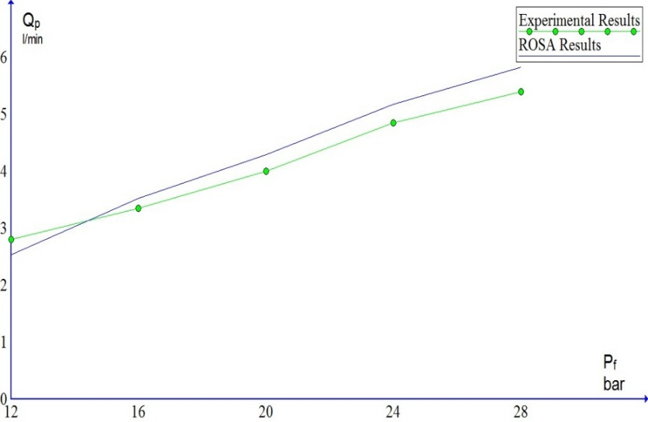
Figure (12) Effect of feed water pressure on permeate flow rate at feed water TDS = 6000 ppm
- Decreasing in brine flow rate, the average deviation between experimental brine flow rate and ROSA brine flow rate at the lowest feed water pressure of 12 bar was 3%, while at the highest value of feed water pressure of 28 bar the average deviation was 8% as shown in figure (13).
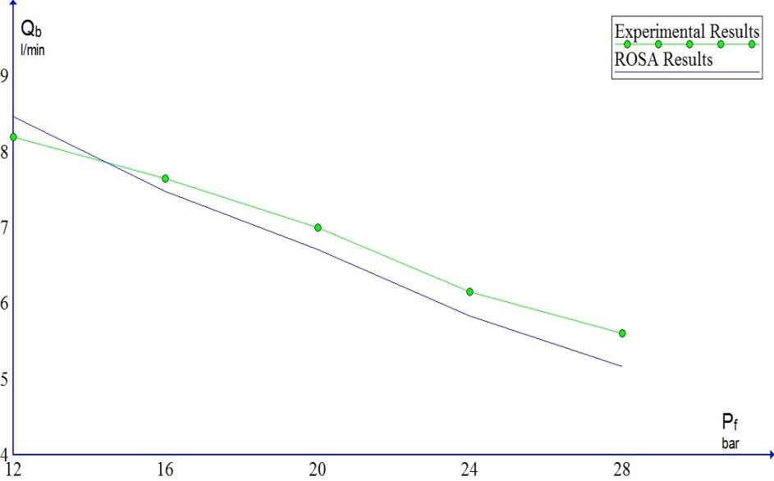
Figure (13) Effect of feed water pressure on brine flow rate at feed water TDS = 6000 ppm
- Increasing in recovery ratio, the average deviation between experimental recovery ratio and ROSA recovery ratio at the lowest feed water pressure of 12 bar was 10%, while at the highest value of feed water pressure 0f 28 bar the average deviation was 7% as shown in figure (14).
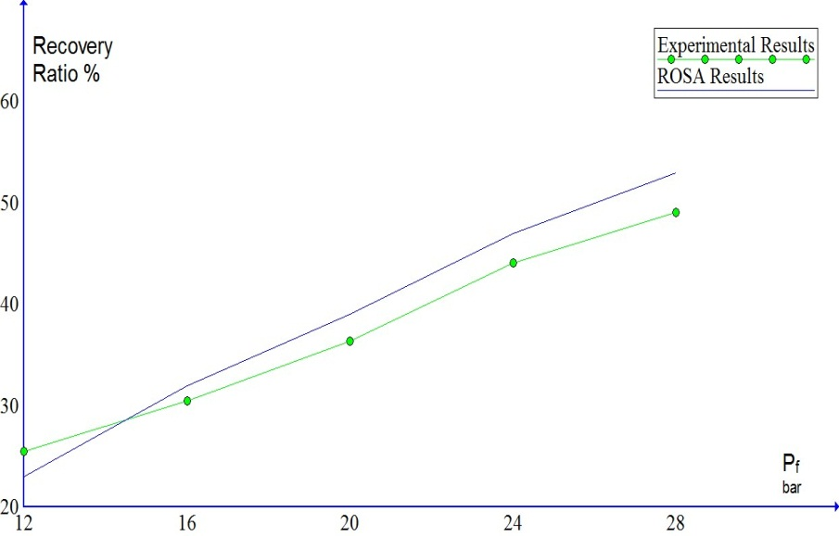
Figure (14) Effect of feed water pressure on recovery ratio at feed water TDS = 6000 ppm

- Decrease in permeate TDS, the average deviation between experimental permeate TDS and ROSA permeate TDS at the lowest feed water pressure of 12 bar was 32 ppm, while at the highest value of feed water pressure 0f 28 bar the average deviation was 25 ppm as shown in figure (15).
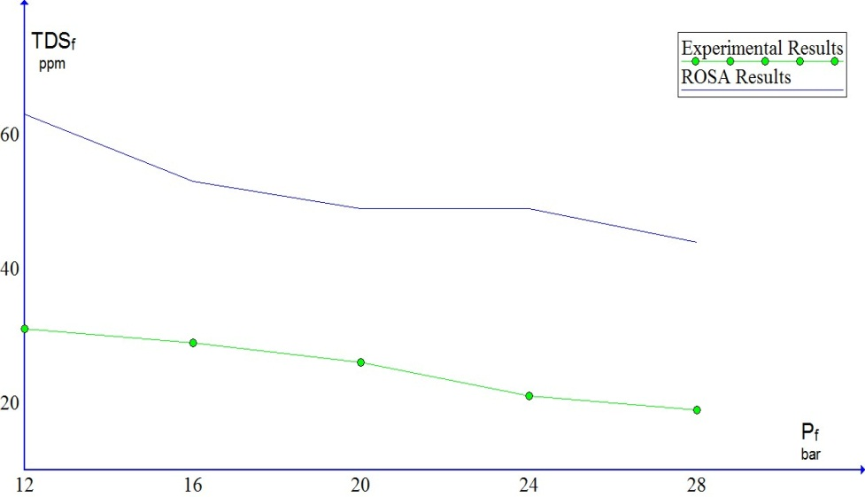
Figure (15) Effect of feed water pressure on permeate TDS at feed water TDS = 6000 ppm

- Decreasing in SEC, the average deviation between experimental SEC and ROSA SEC at the lowest feed water pressure of 12 bar was 10%, while at the highest value of feed water pressure of 28 bar the average deviation was 6% as shown in figure (16).
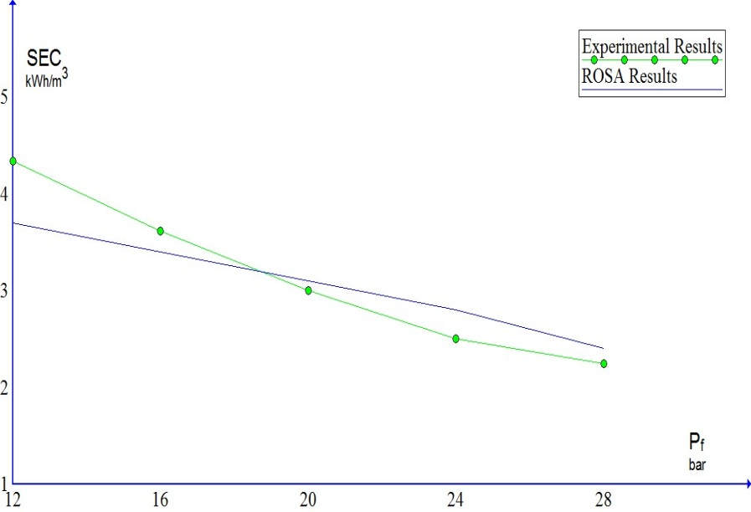
Figure (16) Effect of feed water pressure on SEC at feed water TDS = 6000 ppm
Conclusion
The following conclusions for the effect of feed water pressure can be obtained for permeate water produced, brine rejected, recovery ratio, permeate TDS and specific power consumption at different feed water TDS, feed water temperature:
- At constant feed water TDS, temperature and feed water pressure increases the permeate flow rate and the recovery ratio increase while brine rejected, permeate TDS and specific power consumption decrease.
- At constant feed water pressure, temperature and feed water TDS increases the permeate flow rate and the recovery ratio decrease while brine rejected, permeate TDS and specific power consumption increase.
- At constant feed water pressure and TDS, feed water temperature increases the permeate flow rate, permeate TDS and the recovery ratio increase while brine rejected, and specific power consumption decrease.

REFERENCES
[1] Ahmed R. Allam, Ele-Jan Saaf, Mohamed A. Dawoud, "Desalination of brackish groundwater in Egypt", Desalination, 152 (2002) 19–26.
[2] M. R. El Tahlawi , A. A. Farrag , S. S. Ahmed, " Groundwater of Egypt: ‘‘an environmental overview’’, Environmental Geology , August 2008.
[3] Mariam G. Salim, "Selection of groundwater sites in Egypt, using geographic
information systems, for desalination by solar energy in order to reduce greenhouse
gases", Advanced Research, (2012) 3, 11-19.
[4] Kamal Hefny, M. Samir Farid and Mohamed Hussein," Groundwater assessment
in Egypt", Water Resorces Development, Volume 8 Number 2, June 1992.
[5] Mohamed Ismail, Abd El-Hamid Attia, Samy El-Sherbiny, "Performance Evaluation of Small Scale RO Unit", International Journal of Mechanical and Production Engineering, Volume- 6, Issue(4), 2018.
[6] S. Suleiman, A. Meree, M. AL-Shiakh, F. Kroma, "Performance of RO plant with solar preheated feed water", Desalination and Water Treatment, 28 (2011) 345–352.
[7] Berge Djebedjian, Helmy Gad, Ibrahim Khaled, Magdy Abou Rayan, “An Experimental investigation on the operating parameters affecting the performance of reverse osmosis desalination system,” Tenth International Water Technology Conference. , 2006, Alexandria, Egypt.
[8] H.Elfil, A.Hamed, A.Hannachi, “Technical evaluation of a small scale reverse osmosis desalination unit for domestic water,” Desalination, 2007, vol. 203, 319–326.
[9] Adnan M.Aish, “Water quality evaluation of small scale desalination plants in the Gaza Strip Palestine,”, Desalination and water treatment, 2010.
[10] AlirezaZirakrad, Seyed Jamalodin Hashemian, Mohammad Taghi Ghaneian, “Performance study of reverse osmosis plants for water desalination in Bander Lengeh, Iran,” Community Health Research, 2013, vol. 2, 8–14.
[11] Nada. El Harrak, Fatima.Elazhar, Abdel Ali. Zdeg, Nourdine. Zouhri, Maryem. Elazhar, “ Performance analysis of the reverse osmosis desalination plant of brackish water used for irrigation: Case study,” American Journal of Applied Chemistry., 2013, vol. 1, 43–48.
[12] Mona A Abdel-Fatah, Marwa M Elsayed, Gh A Al Bazedi, “Design of reverse osmosis desalination plant in Suez city (case study)”, Journal of Scientific and Engineering Research, 2016, vol. 3, 149–156.

