MODEL VALIDATION FOR BIGELOW EXPANDABLE ACTIVITy MODULE (beam) with stowage
Sydney Taylor, Zaida Hernandez, and John Iovine
NASA Johnson Space Center, Houston TX 77058

ABSTRACT
The Bigelow Expandable Activity Module (BEAM) was a collaboration between NASA and Bigelow Aerospace to develop an expandable habitat technology that could be used for future space exploration missions such as the Artemis program. On April 26, 2016, the BEAM was launched and berthed to the International Space Station (ISS) on the aft port of Node 3. After the originally planned two-year mission life, BEAM was approved for use as a stowage module for a 109-cargo transfer bag equivalent (CTBE) to alleviate stowage limitations onboard the ISS. The present work builds on the previous 2017 model validation to flight data that demonstrated that BEAM could generally accommodate cargo stowage without adversely affecting BEAM thermal control, primarily for condensation management. Once the stowage was configured in early 2019, model validation efforts resumed. The thermal model revisions included the CTBE stowage and updated CFD-derived heat transfer coefficients for various intra-module ventilation (IMV) flow rates. The coefficients were provided by the Crew and Thermal Systems Division (EC) at NASA JSC and Jacobs Technology. The model is now revalidated and able to predict minimum temperatures with good agreement to flight temperatures (within 1 °C) for both historic and recurring minimum values. Additionally, the model is partially validated for reduced flow rates. With this model, the team was able to provide new flight rule recommendations for condensation and IMV operations management.

Nomenclature, Acronyms, Abbreviations
CFD computational fluid dynamics
CFM cubic feet per minute
CTBE cargo transfer bag equivalent
GMT Greenwich Mean Time
HTC heat transfer coefficients
IMV intra-module ventilation
ISS International Space Station
MMOD micrometeoroid orbital debris
PSARJ port solar array alpha rotary joints
PTRRJ port thermal radiator rotary joints
SSARJ starboard solar array rotary joints
STRRJ starboard thermal radiator rotary joints
WTS wired temperature sensors

INTRODUCTION
The National Aeronautics and Space Administration collaborated with Bigelow Aerospace to develop the Bigelow Expandable Activity Module (BEAM). BEAM was part of an initiative to develop expandable habitat technology that could be used in future space exploration missions, such as the Artemis Program, which will put the first woman and next man on the moon by 2024. Expandable habitats yield many advantages over traditional habitat modules, including low launch mass, impressive volume to habitable volume ratios, radiation shielding options, micrometeoroid orbital debris (MMOD) protection, thermal protection, and opportunity for reduced mission cost [1, 2, 3].
BEAM was launched on April 26, 2016 aboard a SpaceX Commercial Resupply Mission (CRS-8) and was berthed to the International Space Station on the aft port of Node 3. The BEAM mission was originally planned for two years, but due to stowage limitations onboard the ISS, the module life was extended and BEAM is now being used to store flight hardware. Figure 1 shows the BEAM module in the stowed (packed) and expanded configurations.
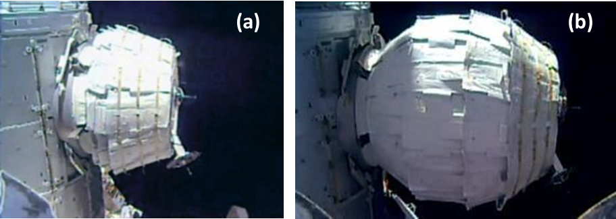
Figure 1. BEAM (a) Stowed vs. (b) Expanded Configuration [1].
BEAM is instrumented to collect radiation, vibration, and temperature data. The temperatures have been collected by the thermal team to monitor thermal performance and understand the effects of the configuration changes both internal and external to the module. In 2017, the temperature sensors were converted from wireless to wired temperature sensors (WTS).
Intra-module ventilation (IMV) jumpers between the Node 3 aft bulkhead and the BEAM forward bulkhead allow an IMV fan to provide airflow through a duct to the BEAM aft bulkhead. The air then returns from the aft bulkhead to exit through the forward bulkhead via the BEAM internal volume. The BEAM nominal IMV flow rate is 120 cubic feet per minute (CFM). The IMV thermal conditioning requires unobstructed ventilation to prevent condensation. Since condensation prevention was a concern, computational fluid dynamics (CFD) analysis was used to calculate the convective heat transfer coefficients (HTC) for the expected IMV flow rates. The HTC were provided by the NASA/JSC Crew and Thermal Systems Division and Jacobs Technology.
The purpose of this study is two-fold: (1) to validate the updated model with stowage using on-orbit flight data and (2) to calculate minimum temperatures within BEAM to provide recommendations for updates to ISS flight rules on dew point management and IMV operations. This study provides a review of the BEAM on-orbit performance to date and describes the thermal model validation work, including cargo stowage and assessment of lower IMV flow rates.

BEAM Configuration and Cargo Stowage
In the stowed (packed) configuration, BEAM is 2.2 m in length and 2.4 m in diameter, while in the expanded configuration, BEAM is 4.0 m in length and 3.2 m in diameter with an internal volume of 16.0 m³. The BEAM is equipped with 16 sensors in total, where 12 are placed around the inner air barrier, two are placed on the forward bulkhead, and two on the aft bulkhead as seen in Figure 2.
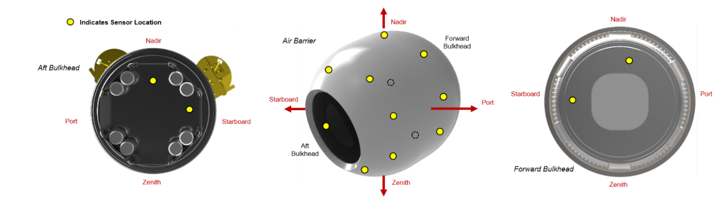
Figure 2. BEAM WTS locations.
The BEAM team evaluated whether BEAM could accommodate cargo stowage without adversely impacting the thermal control via the IMV, where the primary concern was condensation forming in the BEAM. CFD analyses of various cargo volume configurations and IMV duct positions were conducted. The studies concluded that the proposed 109 CTBE stowage configuration would result in minimal impact to the BEAM thermal control.
In late 2017, final preparations were completed for cargo stowage inside the BEAM and the thermal environments were defined for cargo owners to assess [4]. On November 21, 2017, the WTS were converted to wired sensors. Netting was also added to ensure clearance for the IMV duct flow near the aft bulkhead. The cargo bags were pre-positioned as shown in Figure 3.
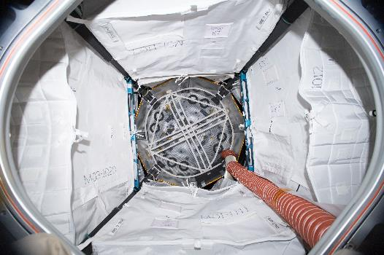
Figure 3. BEAM Cargo Netting and Prepositioned Bags.
The cargo bags inside the BEAM were filled on January 24, 2019 (2019 GMT day 24) to represent the previously approved 109 CTBE configuration. The CTBE are divided into three categories based on size and location: four MO3 (45.8 CTBE), four MO1 (27.4 CTBE) and 12 triples (36 CTBE). The locations and layout are shown in Figure 4.
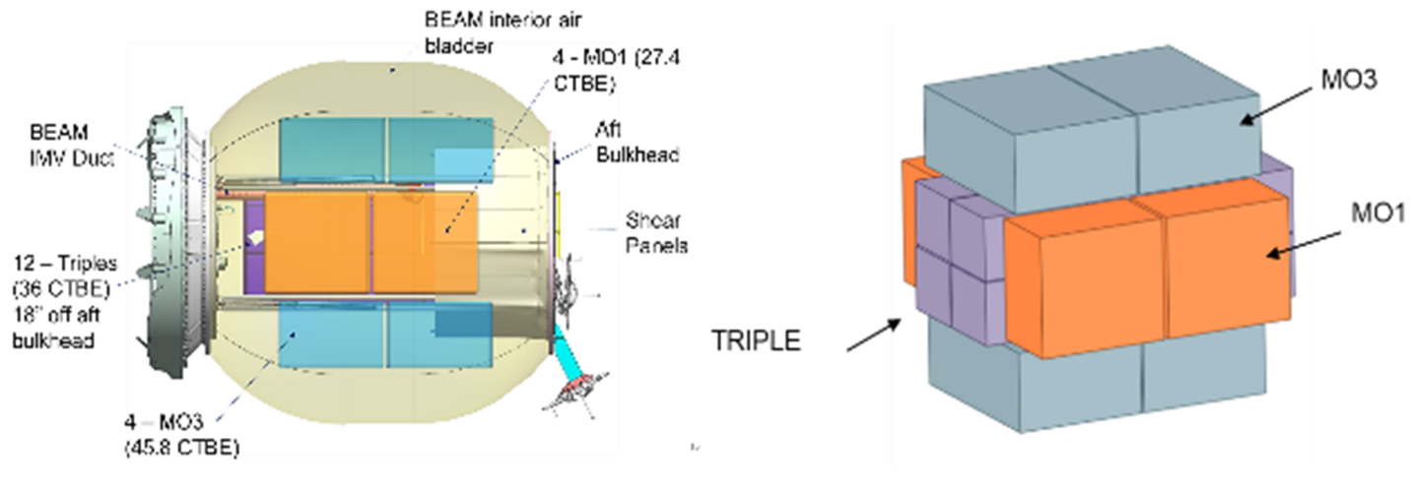
Figure 4. BEAM CTBE Locations and Layout.
After the 109 CTBE stowage was completed, the WTS flight data was monitored for approximately 60 days to confirm that the stowage would have minimal impact at a nominal IMV flow of 120 CFM, as the CFD analysis had previously indicated. It is important to note that neither extreme environment nor reduced IMV flow were encountered over this period.

OVERVIEW OF ON-ORBIT PERFORMANCE AND MODEL VALIDATION CASES
Using the WTS data, on-orbit performance of the BEAM is monitored and reported on a quarterly basis. Figure 5 shows the flight data for 2019, where WTS data vs solar beta angle is provided for all sensors. Red represents the aft bulkhead temperatures, blue represents the forward bulkhead temperatures, and black represents the air barrier sensors. Three minimum temperature events were observed in 2019, as seen in Figure 5: July 2019 (GMT 200), October 2019 (GMT 292), and December 2019 (GMT 350). These events form the basis for the BEAM with stowage model validation.
In July 2019, the BEAM reached an all-time low temperature of nearly 14 °C on the aft bulkhead, as indicated by the orange box in Figure 5. A plot spanning the month of July 2019 can be seen in Figure 6. During this period, there was a maneuver from the ISS nominal +XVV attitude to –XVV [5] to avoid parking the P6 solar array beta gimbal assembly (BGA) for power channel 2B. This BGA is normally parked at high positive solar beta angles in the +XVV attitude due to a BGA stall risk. The –XVV attitude at high positive solar beta angle exposed BEAM to full ISS shadow (normally occurring in the +XVV attitude and high negative beta) and the annual minimum solar flux simultaneously. The 14.4 °C recorded is marginally above the flight rule max allowable BEAM dew point of 14.0 °C per flight rule B17-372 Table II (PTRRJ -40, 72 °F IMV, +XVV attitude, and -75 degrees beta) [6]. An IMV flow reading of 106 CFM was also recorded during this time, compared with the 90 CFM value assumed in the flight rule.
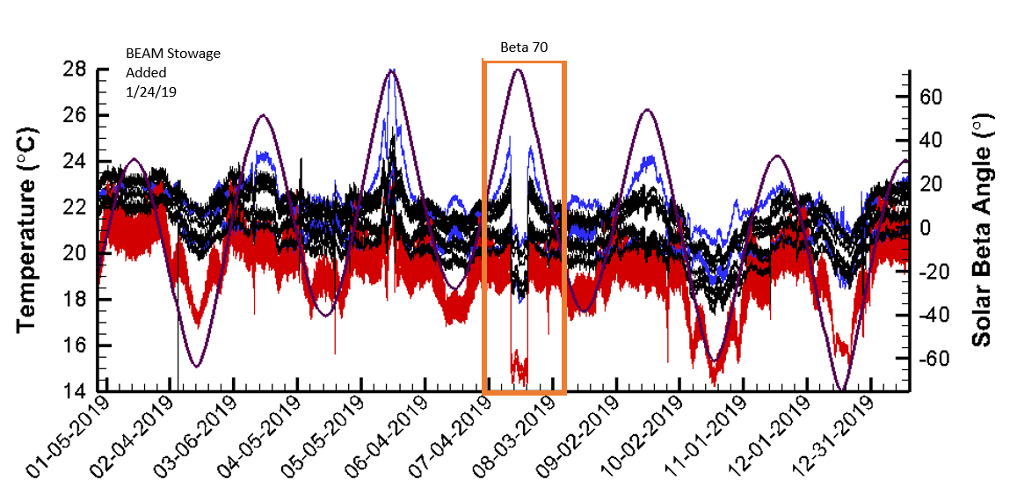
Figure 5. BEAM WTS 2019 temperatures (°C) vs. solar beta angle (°) for all sensors.

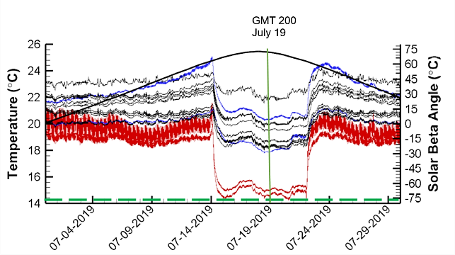
Figure 6. BEAM WTS July 2019 temperatures (°C) vs. solar beta angle (°).
In October 2019 the BEAM experienced its only low flow event since the stowage had been added in January 2019. An IMV flow reading of 50 CFM was reported on 10/21/2019 (2019 GMT day 295). Other low flow events had taken place prior to stowage, but October 2019 marked the first time that the BEAM temperatures were appreciably impacted by lower CFM. The monthly plot for October 2019 is show in Figure 7.

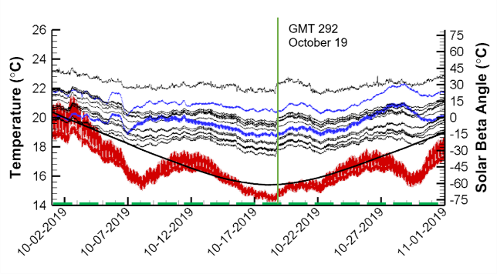
Figure 7. BEAM WTS October 2019 temperatures (°C) vs. solar beta angle (°).
The only other confirmed low flow period is from 2017, where the WTS readings began to show a slight cooling trend in August 2017 with an approximately 66 CFM reading on August 24 and an approximately 45 CFM reading on September 21.
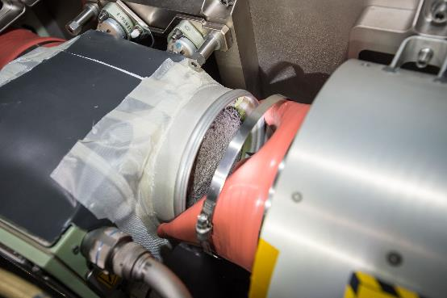
Figure 8. Node 3 Aft Port Fan Blockage.
The WTS had trended slightly cooler, but still above the ISS maximum specification for dew point (15.6 °C). The temperature trend is shown in Figure 9 [7].
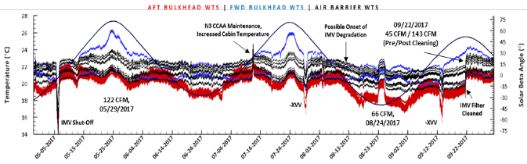
Figure 9. BEAM WTS temperatures (°C) trend from 2017 low CFM period.
The October 2019 low flow event and corresponding temperatures are significantly out of family with past periods at similar time of year and beta angle. Figure 10 shows the WTS temperatures and solar beta angles from BEAM start of life to August 2019. Instances where the time of year and solar beta angle (-60 degree) are comparable to the October 2019 low flow event are outlined in green. The October 2019 low flow caused over 2 °C cooling in the BEAM aft bulkhead temperatures, with the recorded temperature approaching 14 °C. This temperature is equivalent to the all-time low seen in July 2019, when BEAM was exposed to its coldest environment to date.
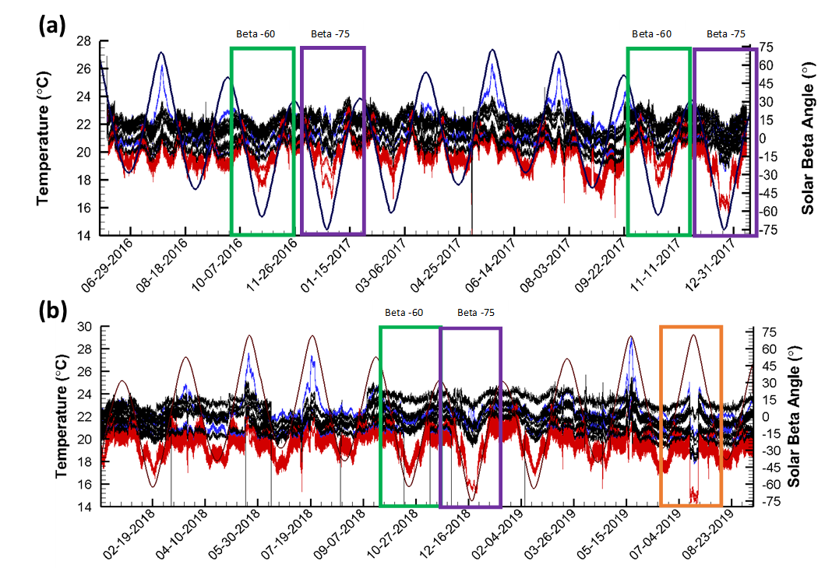
Figure 10. WTS temperatures (°C) vs solar beta angle (°) for (a) 2016-2017 and (b) 2018-2019.
In addition to the singular low temperature events discussed above, BEAM also experiences an annual cold case in the December time frame, when the ISS approaches a minimum beta angle of -75 degrees. Looking back at historical BEAM temperatures since December 2016, the minimum temperatures observed during this annual cold case have decreased (outlined in purple in Figure 10). This was first noted in December 2017 after the November 21, 2017 wireless to wired sensor conversion and installation of the stowage netting and bags. Since the sensor calibration was reported to be unaffected by the conversion, the cooler temperatures were attributed to the netting and bags.
Temperatures further cooled in December 2018 but appear to have levelled off in December 2019. Note that full stowage in BEAM was not realized until January 2019. The comparative cooling from December 2017 to December 2018 has not been explained. Figure 11 shows the monthly plot for the December 2019 annual cold case.
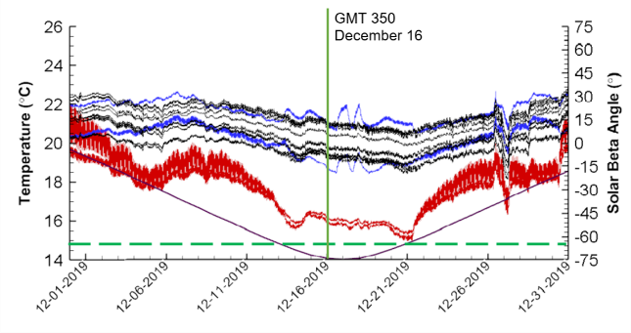
Figure 11. BEAM WTS December 2019 temperatures (°C) vs. solar beta angle (°).
The July, October, and December 2019 events were selected for validation of the BEAM thermal model with the 109 CTBE stowage configuration.

BEAM tHERMAL MODEL VALIDATION
Figure 12 shows the aft bulkhead and other component locations on the BEAM. The current iteration of the BEAM model shown in Figure 12 includes the CTBE and as well as the CFD-derived HTC for the baseline and selected lower flow rates (120, 90, 60, and 30 CFM). The original model, developed by Applied Technology Associates (ATA) for ISS verification analysis, used CFD-based HTC from ATA.
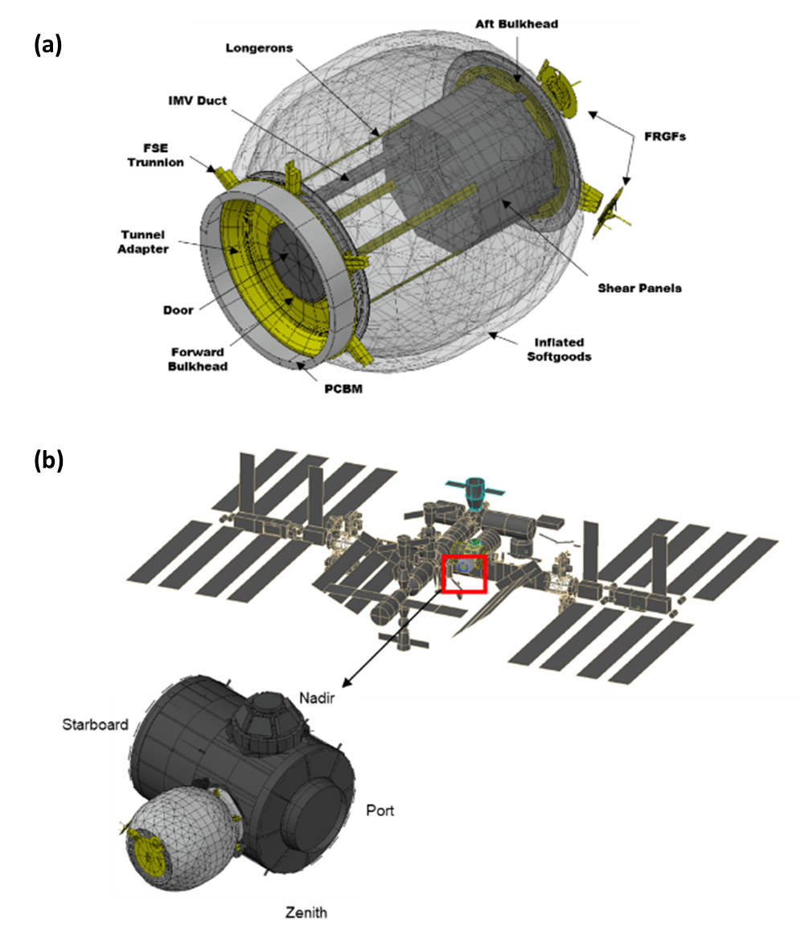
Figure 12. (a) BEAM Components and (b) Thermal Model [1].
In 2017, a model validation effort was initiated to better correlate model results to flight data. The model has nodes that correspond to the 16 WTS locations. These nodes are plotted for comparison to the flight data. The ATA-developed thermal model was used to run a baseline analysis that concluded that the model was under predicting flight data by 5-6 °C. The team acknowledged that the ATA-derived HTC were lower than similar data previously provided by Jacobs, and that the ATA data had been used to maintain a lower temperature bound for BEAM verification. However, as a result of initial model validation findings, the team decided to replace the ATA data with the higher CFD-derived HTC from Jacobs.
Further review led to additional changes with focus on structural heat leak sources. To better reconcile the air barrier temperatures, more isolation from the BEAM debris shield assembly was required. Because this design is proprietary, the team simply added an additional radiation barrier at this interface, and an effective emittance (known as e-star or e*) of 0.075 was chosen as a best fit. To better reconcile the aft bulkhead temperatures, couplings to the soft goods attachment ring and the Flight Releasable Grapple Fixture (FRGF) were further scrutinized and adjusted. As a result of these model adjustments, the model predictions were typically within 1 °C of the WTS while some brief instances had differences on the order of 2 °C [8].
The model validation resumed in 2019, after flight data for the BEAM with stowage became available and updated CFD analysis that included the cargo bags was completed [9]. When model validation resumed in 2019, the date-specific flight cases required many different parameters to be considered, including visiting vehicle configurations, beta angle, angles for Port and Starboard Thermal Radiator Rotary Joints (PTRRJ/STRRJ) seen in Figure 13(a), and Port and Starboard Solar Array Alpha Rotary Joints (PSARJ/SSARJ) seen in Figure 13(b). Table 1 summarizes the parameters used in the three model validation cases.
Table 1. Model Validation Parameters.
Parameter | GMT 200  (July 2019) | GMT 292  (October 2019) | GMT 350 (December 2019)
Beta Angle (deg) | +72 | -60 | -75
Yaw/Pitch/Roll | 185.0/-3.8/0.7 | -4/-1/1 | +4/-1/+1
Solar Constant (BTU/hr/ft²) | 419 | 437 | 447
OLR (BTU/hr/ft²) | 76 | 76 | 76
Albedo | 0.27 | 0.27 | 0.27
PTRRJ | -40 | -40 | -40
STRRJ | +60 | +25 | +55
PSARJ | Auto-track (AT) | AT | AT
SSARJ | AT | AT | AT
Flow Rate  (CFM) | 120 | 60 | 120
HTC | See Appendix A | See Appendix A | See Appendix A
Visiting Vehicles | FGB/MRM1: Soyuz  N1N: Dragon  N2N: Cygnus | FGB/MRM1: None  N1N: Dragon  N2N: None | FGB/MRM1: None  N1N: Dragon  N2N: Cygnus
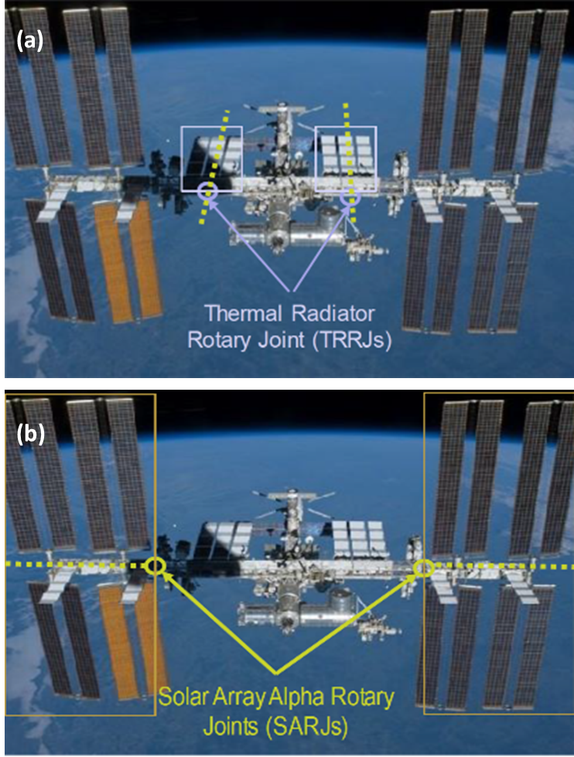
Figure 13. BEAM (a) Thermal Radiator Rotary Joints and (b) Solar Alpha Rotary Joints.
The more recent flight data indicates an additional warm-bias in the 2017 model, where the BEAM minimum internal temperatures at the aft bulkhead sensor locations was now over-predicted by approximately 3 °C for the minimum temperatures seen during the annual December cold case when the beta angles approach -75 degrees.
Initial efforts in 2019 again focused on structural heat leak sources. The conduction coefficient between the soft goods ring and the aft bulkhead was revisited with reductions to 50 and 10 percent of the existing model value. Another attempt involved an increase to the e* value for the aft bulkhead MLI from 0.02 to 0.05. These changes were discarded as they did not have a significant impact on the temperature results (less than 0.5 °C). Furthermore, the team concluded that the IMV flow was the dominant heat source for the aft bulkhead.
Once the structural heat leaks were exhausted as a source of temperature over-prediction, and since these heat leaks were not expected to vary over time under recurring similar conditions, a decision was made to examine potential degradation of the convective heat transfer coefficients derived from CFD analysis due to stowage. The final attempt at refining the model was to degrade the HTC on the aft bulkhead with factors between ten and thirty percent of the original value. Results showed that the closest match to the flight data was obtained when the HTC was degraded to ten percent of the CFD derived values.
The minimum temperature predictions were produced by running the model for 35 to 75 hours, until the temperature reached steady state, and then determining the lowest temperature seen on the BEAM (typically observed on the aft bulkhead). A sample model output is included in Figure 14. Table 2 summarizes the minimum temperature predicted for the model validation cases.
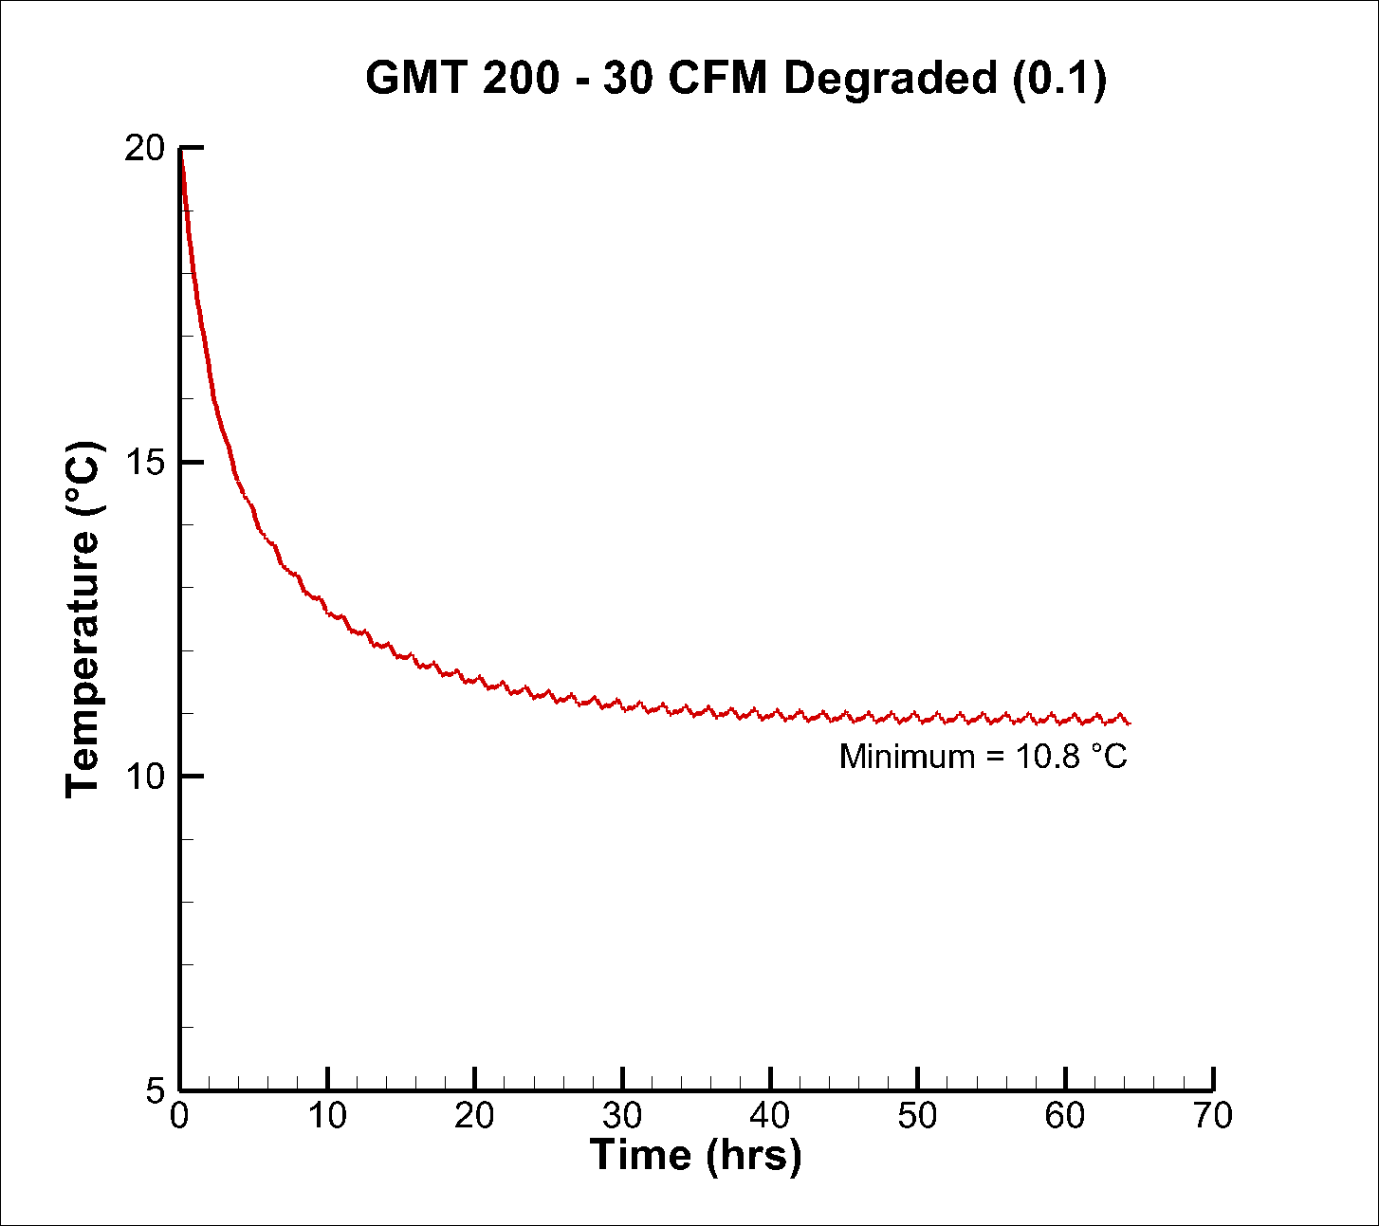
Figure 14. Sample output for the revised BEAM model.
The table includes the predictions for the model with the original HTC as well as with the degraded HTC on the aft bulkhead. The ten percent factor for the 120 CFM was determined and validated with the 2017 December case and the 2019 July and December cases. The results for the original and degraded HTCs for each model validation case are shown in Table 2. The original and degraded HTC coefficients are shown in Table 3. From the results, it can be observed that the degraded minimum temperature is in good agreement with the flight minimum temperatures (within 1 °C).
Table 2. Model Validation Case Results: PTRRJ = -40.
Date | GMT | CFM | Min Temp °C (baseline) | Min Temp °C (degraded) | Delta | Flight Min Temp Date | Flight Min Temp °C | IMV Inlet Temp °F
19-Jul | GMT 200 | 120 | 17.6 | 14.3 | 3.3 | GMT 201 | 14.4 | 72
19-Oct | GMT 292 | 60 | 17.4 | 15.4 | 2 | GMT 291 | 14.1 | 72
19-Oct | GMT 292 | 30 | 15.5 | 13.9 | 1.6 | GMT 291 | 14.1 | 72
19-Dec | GMT 350 | 120 | 17.5 | 14 | 3.5 | GMT 355 | 15.0 | 72
17-Aug | GMT 239 | 60 | 16.7 | 14.3 | 2.4 | GMT 243 | 16.3 | 72

Table 3. Model HTC Aft Bulkhead Coefficients.
HTC | 120 CFM | 90 CFM | 60 CFM | 30 CFM
HTC Inside Shear Panel (aft bulkhead) | 2.015 | 1.6256 | 1.2663 | 0.8982
HTC Outside Shear Panel (aft bulkhead) | 1.624 | 0.6393 | 0.5090 | 0.3153
HTC Inside Shear Panel (aft bulkhead) degraded | 0.2015 | 0.16256 | 0.12663 | 0.08982
HTC Outside Shear Panel (aft bulkhead) degraded | 0.1624 | 0.06393 | 0.05090 | 0.03153

Degradation at lower CFM was determined and validated with the October 2019 low CFM report of 50 CFM. Recall this marked the first time that the BEAM temperatures were appreciably impacted by lower CFM, and the corresponding temperatures were significantly out of family with past periods at a similar time of year and beta angle. The only other confirmed low flow period in August 2017, where only a minimal cooling effect was observed, predated the cargo netting and bag pre-positioning in November 2017. As can be seen in Table 2, the non-degraded HTC case is in better agreement with the flight data. After the model was validated using the aforementioned model validation cases, additional cases were completed in preparation for flight rule update recommendations. The results of these additional cases are show in Table 4.

Table 4. Flight Rule Update Case Results: PTRRJ = -40.
Date | GMT | CFM | Min Temp °C (baseline) | Min Temp °C (degraded) | Delta | IMV Inlet Temp °F
19-Jul | GMT 200 | 90 | 17.0 | 13.7 | 3.3 | 72
19-Jul | GMT 200 | 60 | 15.8 | 12.9 | 2.9 | 72
19-Jul | GMT 200 | 30 | 13.1 | 10.8 | 2.3 | 72
19-Jul | GMT 200 | 120 | 15.7 | 12.6 | 3.1 | 68
19-Jul | GMT 200 | 90 | 15.0 | 12.0 | 3.0 | 68
19-Jul | GMT 200 | 60 | 14.0 | 11.3 | 2.7 | 68
19-Jul | GMT 200 | 30 | 11.5 | 9.6 | 1.9 | 68

Another way to fly ISS is with the PTRRJ automatically tracking the sun, instead of being at a fixed angle. This is known as Auto-track (AT). Table 5 shows the bounding AT cases for the July 2019 case for nominal and reduced flow. As expected, the AT case results are lower than the fixed PTRRJ.
Table 5. Flight Rule Case Results: PTRRJ = AT.
Date | GMT | CFM | Min Temperature °C (degraded) | IMV Inlet Temp °F
Jul-19 | GMT 200 | 120 | 13.5 | 72
Jul-19 | GMT 200 | 30 | 9.9 | 72

CONCLUSIONS
This paper summarizes the model validation effort to create the latest thermal model revision for BEAM, which includes the 109 CTBE stowage with CFD-derived HTC for the baseline and selected lower flow rates (120, 90, 60, and 30 CFM). Using degraded HTC on the aft bulkhead, the model is now validated for 120 CFM and able to predict the minimum temperature of the aft bulkhead with good agreement to flight minimum temperature (within 1 °C) for both historic and recurring minimum values. Furthermore, the model is partially validated for reduced flow rates, also showing good agreement with the October 2019 flight data. The results from the low flow cases were also used to provide recommendations for updating the BEAM flight rules.

References

[1] | W. Q. Walker and J. Iovine, "Comparison of Analysis to the On-Orbit Thermal Performance of the Bigelow Expandable Activities Module," International Conference on Environmental Systems, Charlestown, SC., 2017.
[2] | "BEAM Facts, Figures, FAQs," NASA, [Online]. Available: https://www.nasa.gov/feature/beam-facts-figures-faqs.
[3] | "BEAM Expandable Activity Module," NASA, [Online]. Available: https://www.nasa.gov/content/bigelow-expandableactivity-module.
[4] | L. Carrillo, D. Farner and C. Preston, "ISS Payload Thermal Environments," Thermal Fluids and Analysis Workshop, 2015.
[5] | Z. Hernandez, "BEAM Thermal Quarterly Report FY19, Quarter," NASA Report, 2019.
[6] | "B17-372 BEAM Dew Point Management. International Space Station Flight Rule.," \\js-ea-fs-01\ws01\ES\Secure_Server\ISS_PTCS\FLIGHT_FOLDERS\SPX-8.
[7] | W. Walker, "BEAM Thermal Quarterly Report FY17, Quarter 4," NASA Report, 2017.
[8] | W. Walker, "Bigelow Expandable Activity Module (Beam) Date Specific Thermal Analysis and Corresponding Model Updates," NASA Internal Presentation, 2017.
[9] | T. Paul, Reduced Flowrate case results and heat transfer coefficients on bags, Jacobs Presentation, May 17, 2019.

